**Task#1:** Create Birthday Card Application.

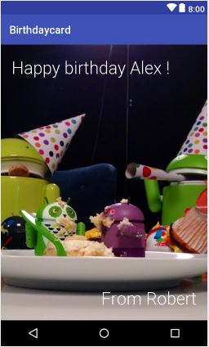

**Solution:**

**XML:**

<?xml version="1.0" encoding="utf-8"?>  
<RelativeLayout xmlns:android="http://schemas.android.com/apk/res/android"  
 xmlns:app="http://schemas.android.com/apk/res-auto"  
 xmlns:tools="http://schemas.android.com/tools"  
 android:layout_width="match_parent"  
 android:layout_height="match_parent"  
 android:background="@drawable/birthday2"  
 tools:context=".MainActivity">  
  
 <TextView  
  
 android:layout_width="wrap_content"  
 android:layout_height="wrap_content"  
 android:layout_marginLeft="20dp"  
 android:layout_marginTop="30dp"  
 android:fontFamily="@font/chango"  
 android:text="@string/to_text"  
 android:textAppearance="?android:textAppearanceLarge"  
 android:textColor="#734E3A"  
 android:textSize="30dp"  
 android:textStyle="bold" />  
  
 <TextView  
  
 android:layout_width="wrap_content"  
 android:layout_height="wrap_content"  
 android:layout_alignParentRight="true"  
 android:layout_alignParentBottom="true"  
 android:layout_marginRight="20dp"  
 android:layout_marginBottom="30dp"  
 android:fontFamily="@font/chango"  
 android:text="@string/from_text"  
 android:textAppearance="?android:textAppearanceLarge"  
 android:textColor="#734E3A"  
 android:textSize="25dp"  
 android:textStyle="bold" />  
  
</RelativeLayout>

**Output:**

**Task#2:** Create Login Page.

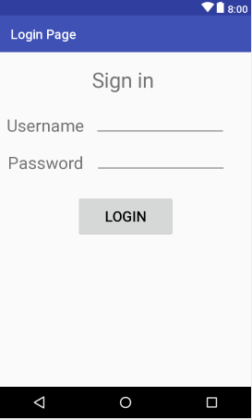

**Solution:**

**XML:**

<?xml version="1.0" encoding="utf-8"?>  
<RelativeLayout xmlns:android="http://schemas.android.com/apk/res/android"  
 xmlns:tools="http://schemas.android.com/tools"  
 android:layout_width="match_parent"  
 android:layout_height="match_parent"  
 tools:context=".MainActivity">  
  
 <LinearLayout  
 android:layout_width="match_parent"  
 android:layout_height="match_parent"  
 android:weightSum="10"  
 android:orientation="vertical">  
  
  
  
 <TextView  
 android:id="@+id/title_text_view"  
 android:layout_width="match_parent"  
 android:layout_height="wrap_content"  
 android:text="Sign In"  
 android:textSize="40dp"  
 android:textAppearance="?android:textAppearanceLarge"  
 android:textStyle="bold"  
 android:textAlignment="center"  
 android:layout_weight="2"/>  
  
 <EditText  
 android:id="@+id/username_view"  
 android:layout_width="match_parent"  
 android:layout_height="wrap_content"  
 android:hint="Username"  
 android:textSize="20dp"  
 />  
 <EditText  
 android:id="@+id/password_view"  
 android:layout_width="match_parent"  
 android:layout_height="wrap_content"  
 android:hint="Password"  
 android:textSize="20dp"  
 android:inputType="textPassword"  
 />  
 <Button  
 android:id="@+id/login_button"  
 android:layout_width="wrap_content"  
 android:layout_height="wrap_content"  
 android:textAlignment="center"  
 android:layout_gravity="center"  
 android:textSize="20dp"  
 android:text="Login" />  
  
 <TextView  
  
 android:layout_width="match_parent"  
 android:layout_height="wrap_content"  
 android:text="Khizar Hayat"  
 android:textSize="20dp"  
 android:textAppearance="?android:textAppearanceLarge"  
 android:textStyle="bold"  
 android:gravity="center"  
 android:textAlignment="center"  
 android:layout_weight="4"/>  
  
  
  
 </LinearLayout>  
  
</RelativeLayout>